1. MAIN PAGE

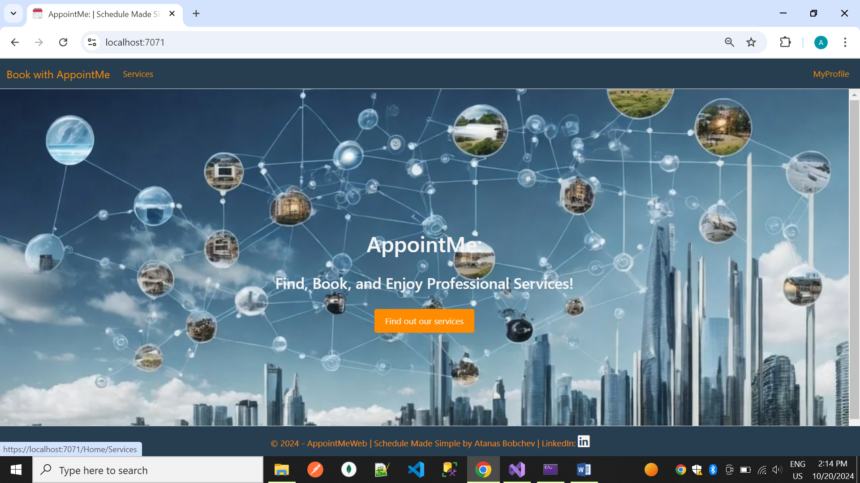

1. MAIN SERVICE PAGE

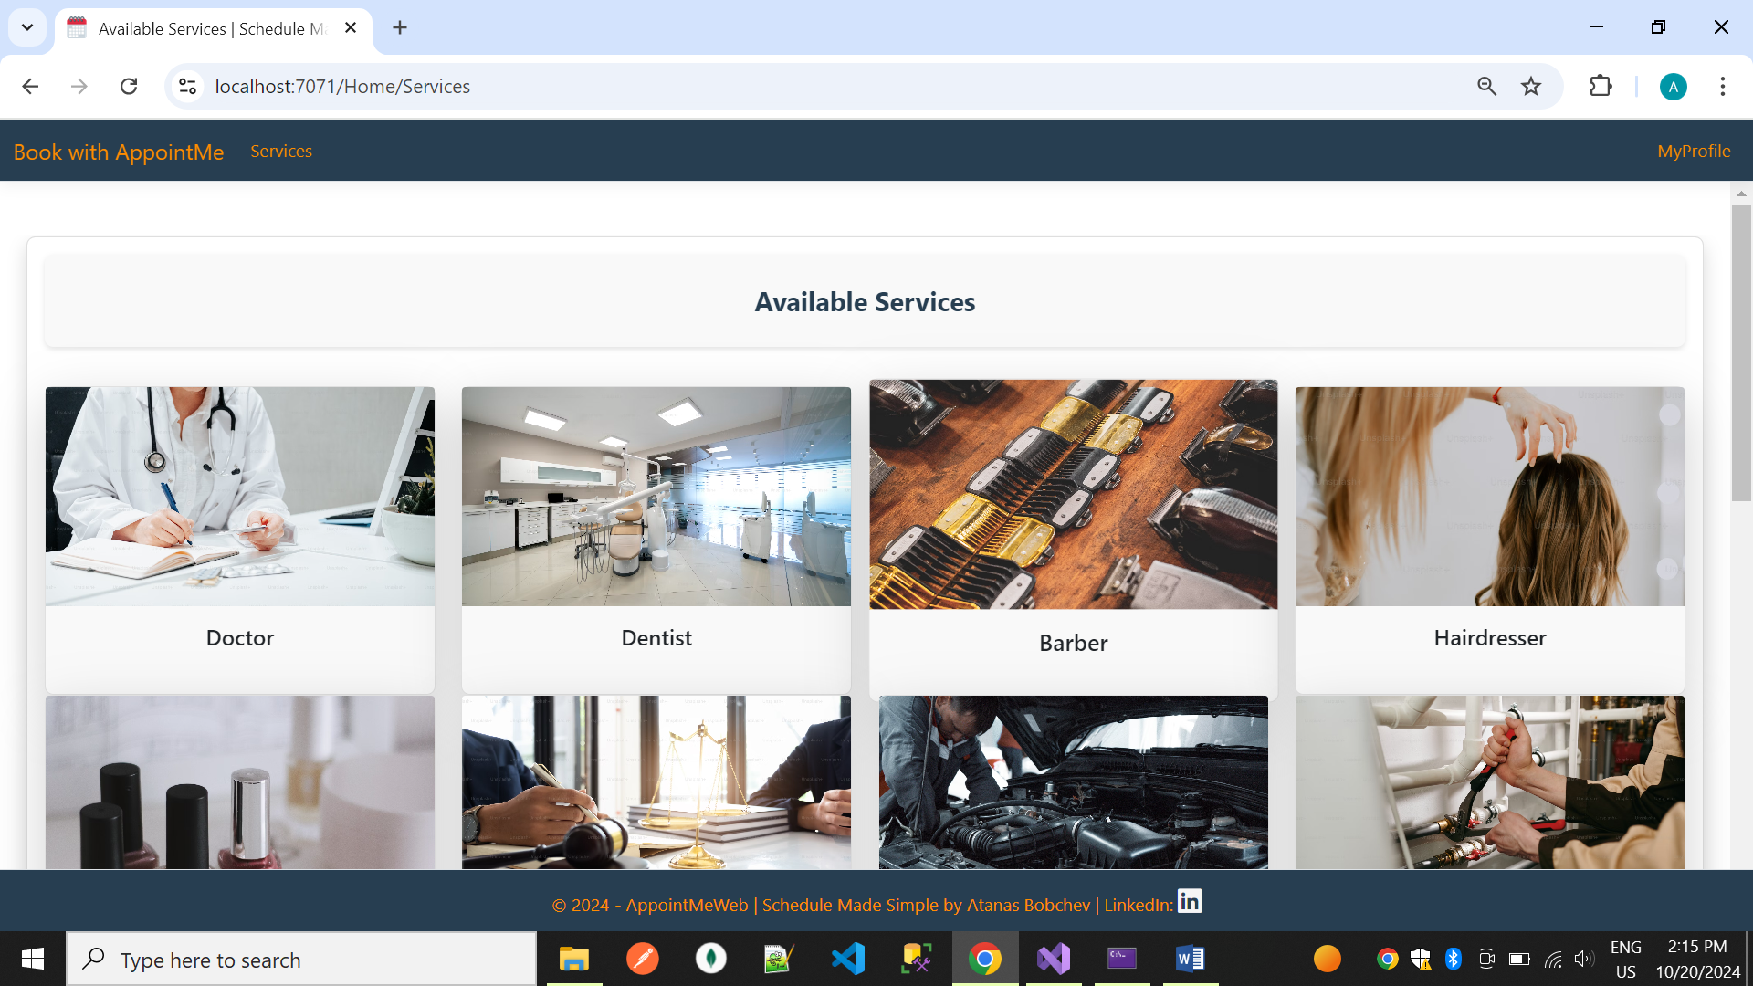

3.MY PROFILE PAGE

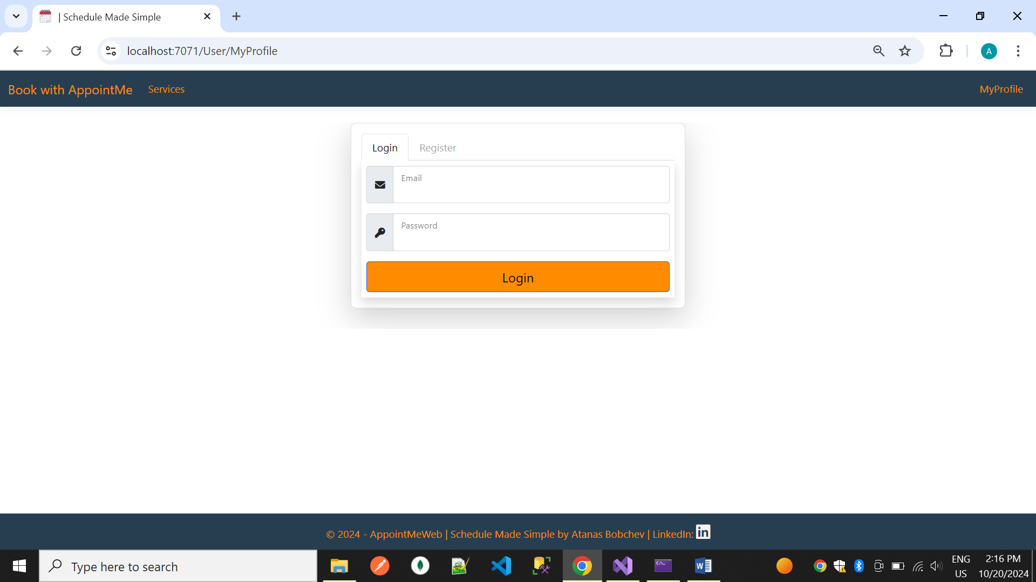

4.REGISTER PAGE

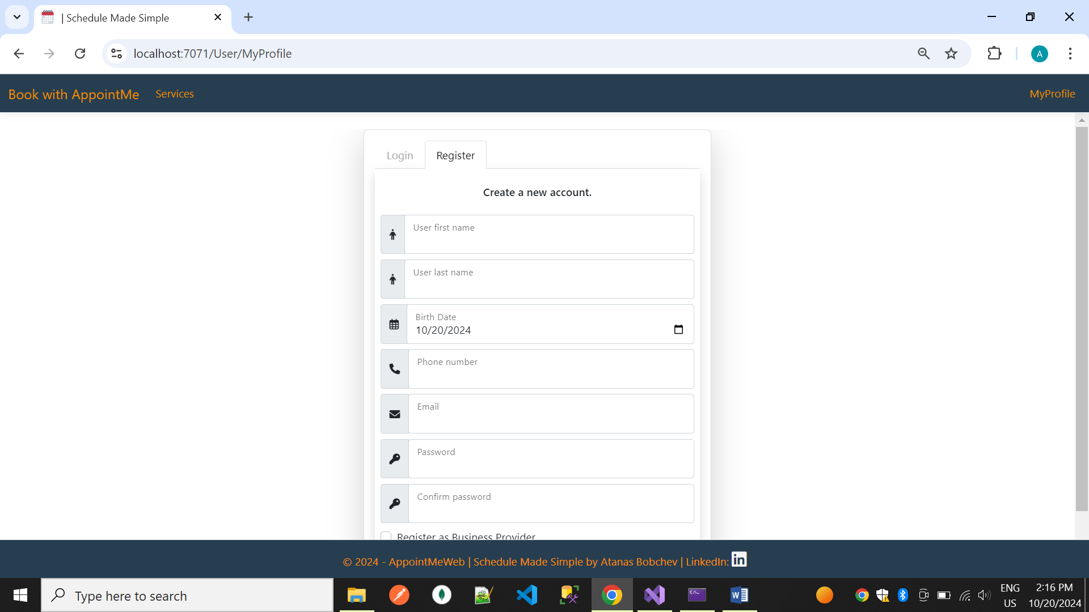

BUSINESS AREA

5.REGISTER AS BUSINESS USER

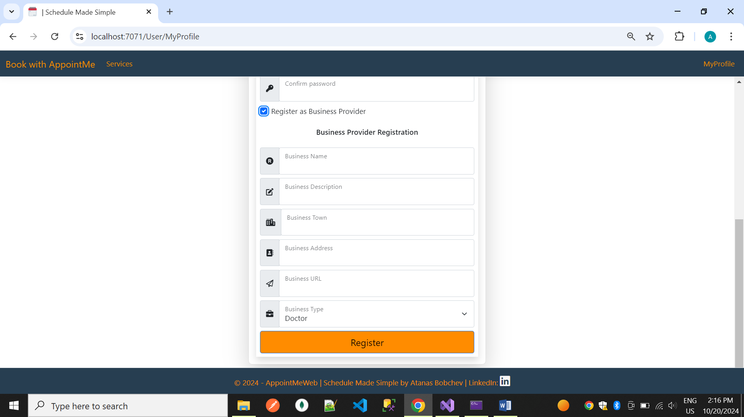

6.Business Setup – working days and hours

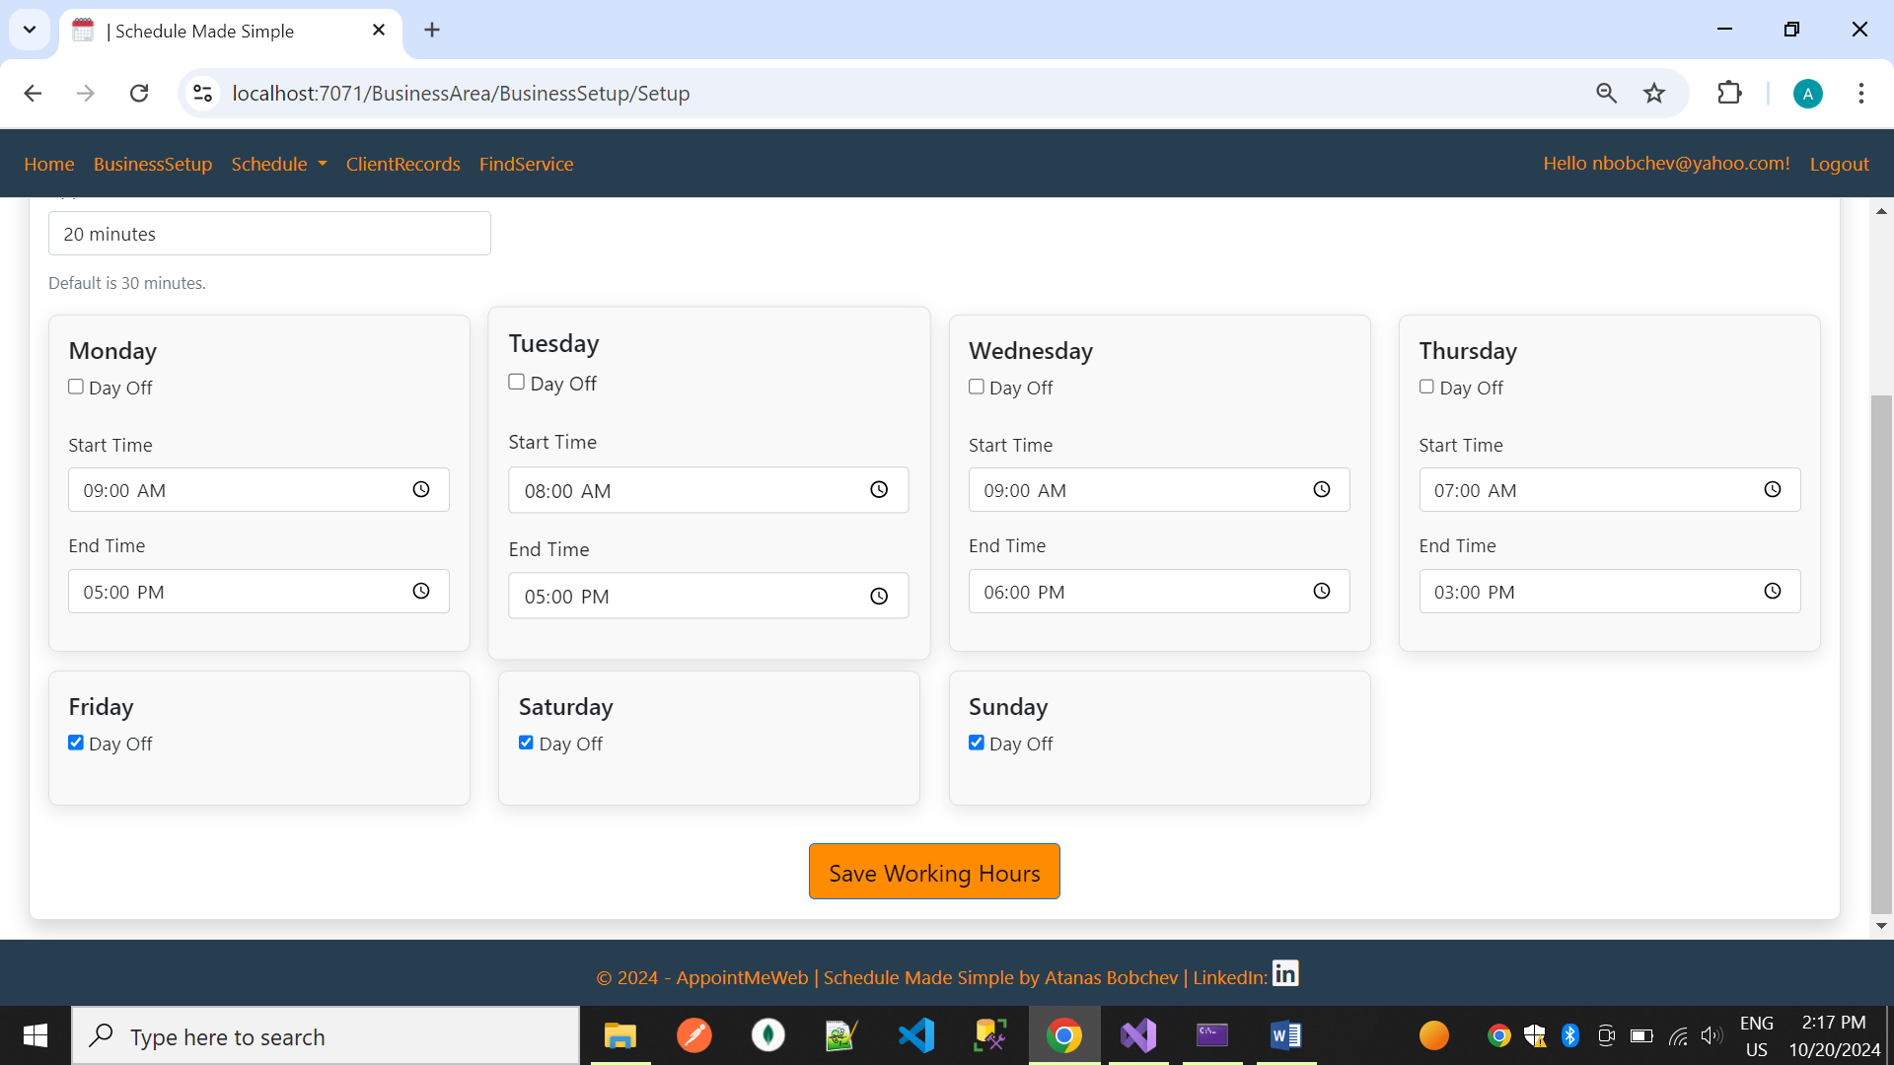

7.BUSINESS SCHEDULE – TODAY



8.BUSINESS SCHEDULE – TOMORROW

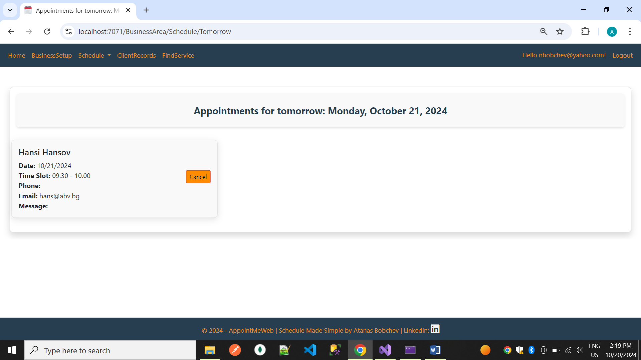

9. BUSINESS APPOINTMENTS NEXT 7 DAYS

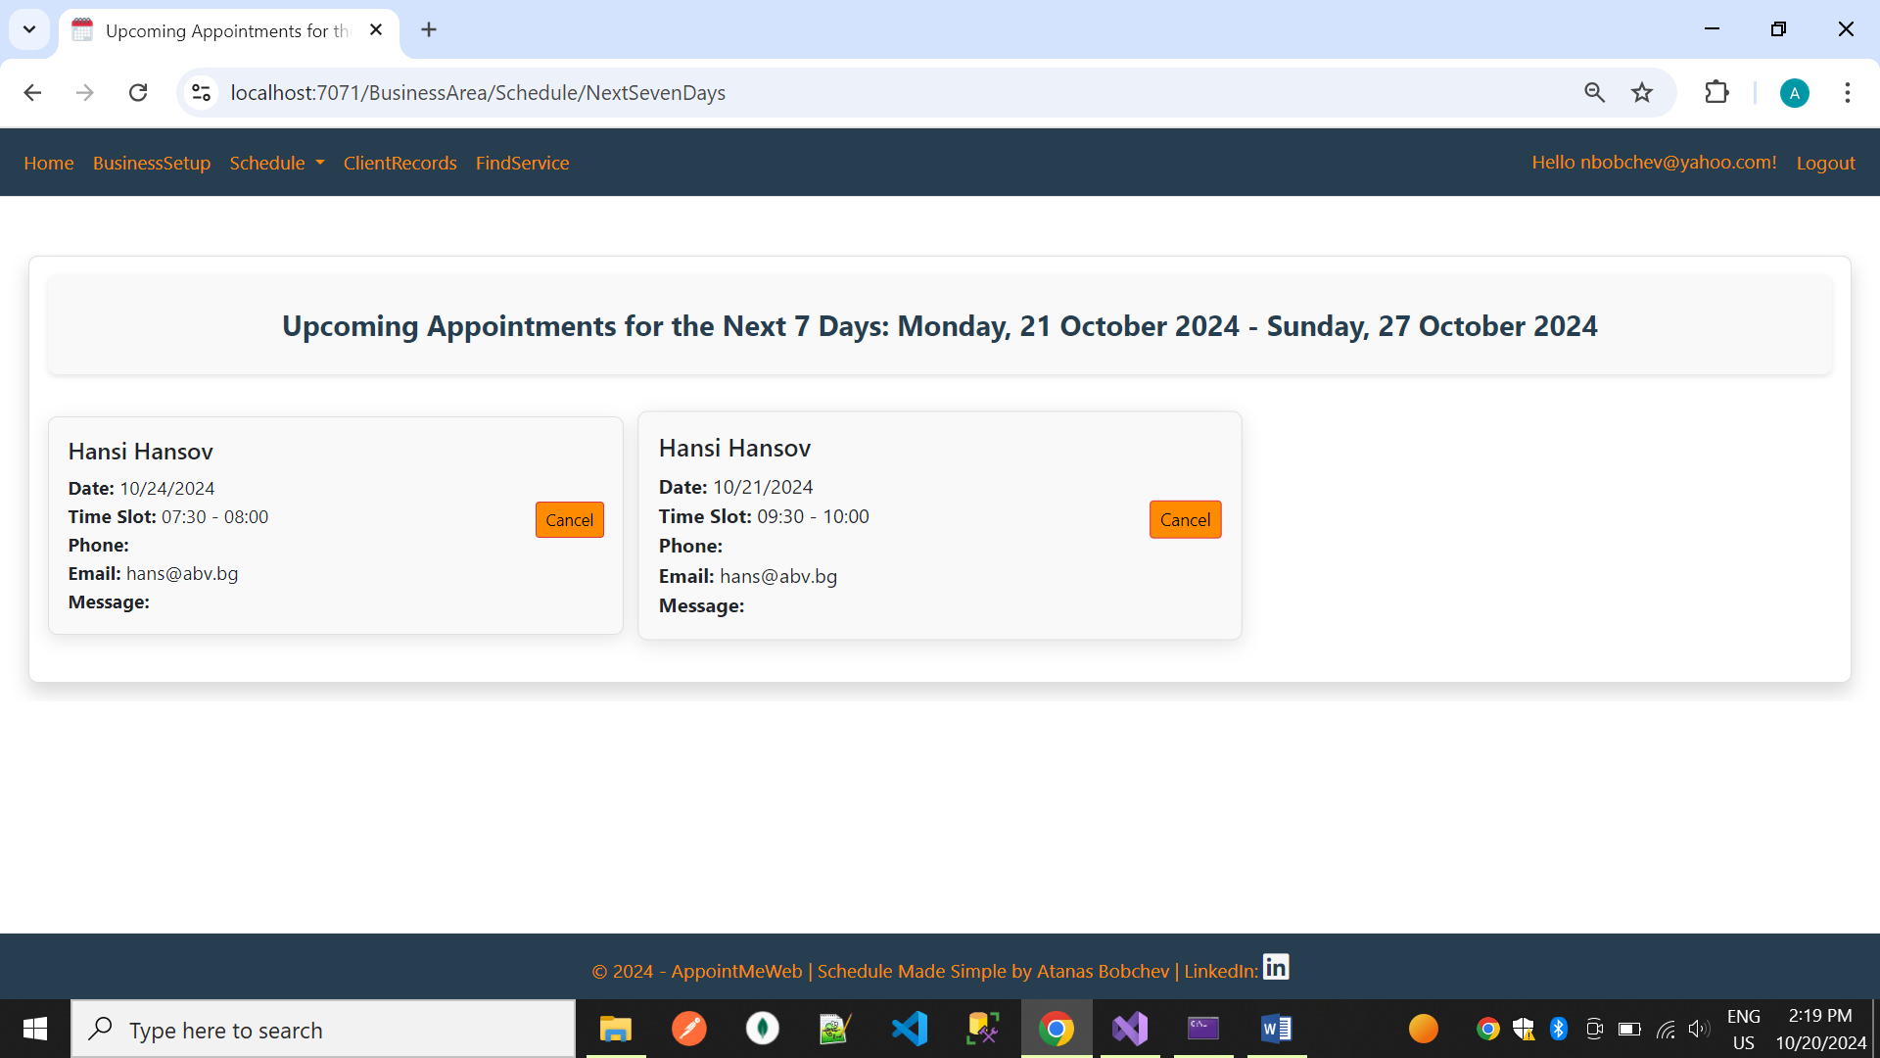

10.DATE RANGE

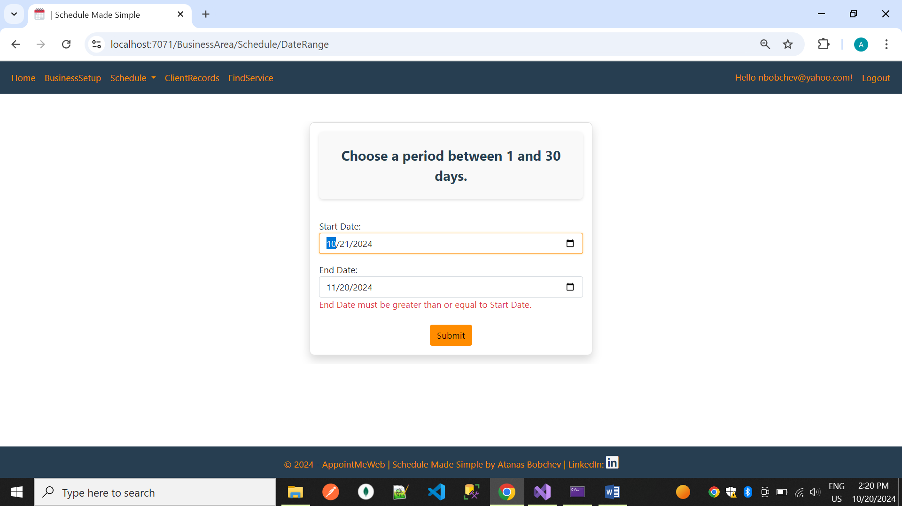

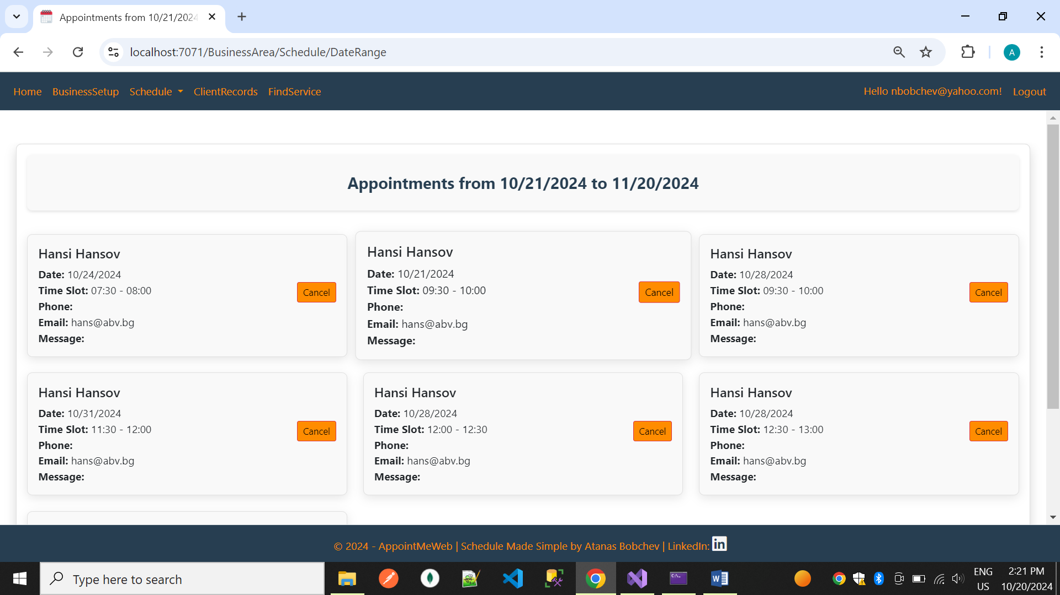

11.CLIENT RECORDS

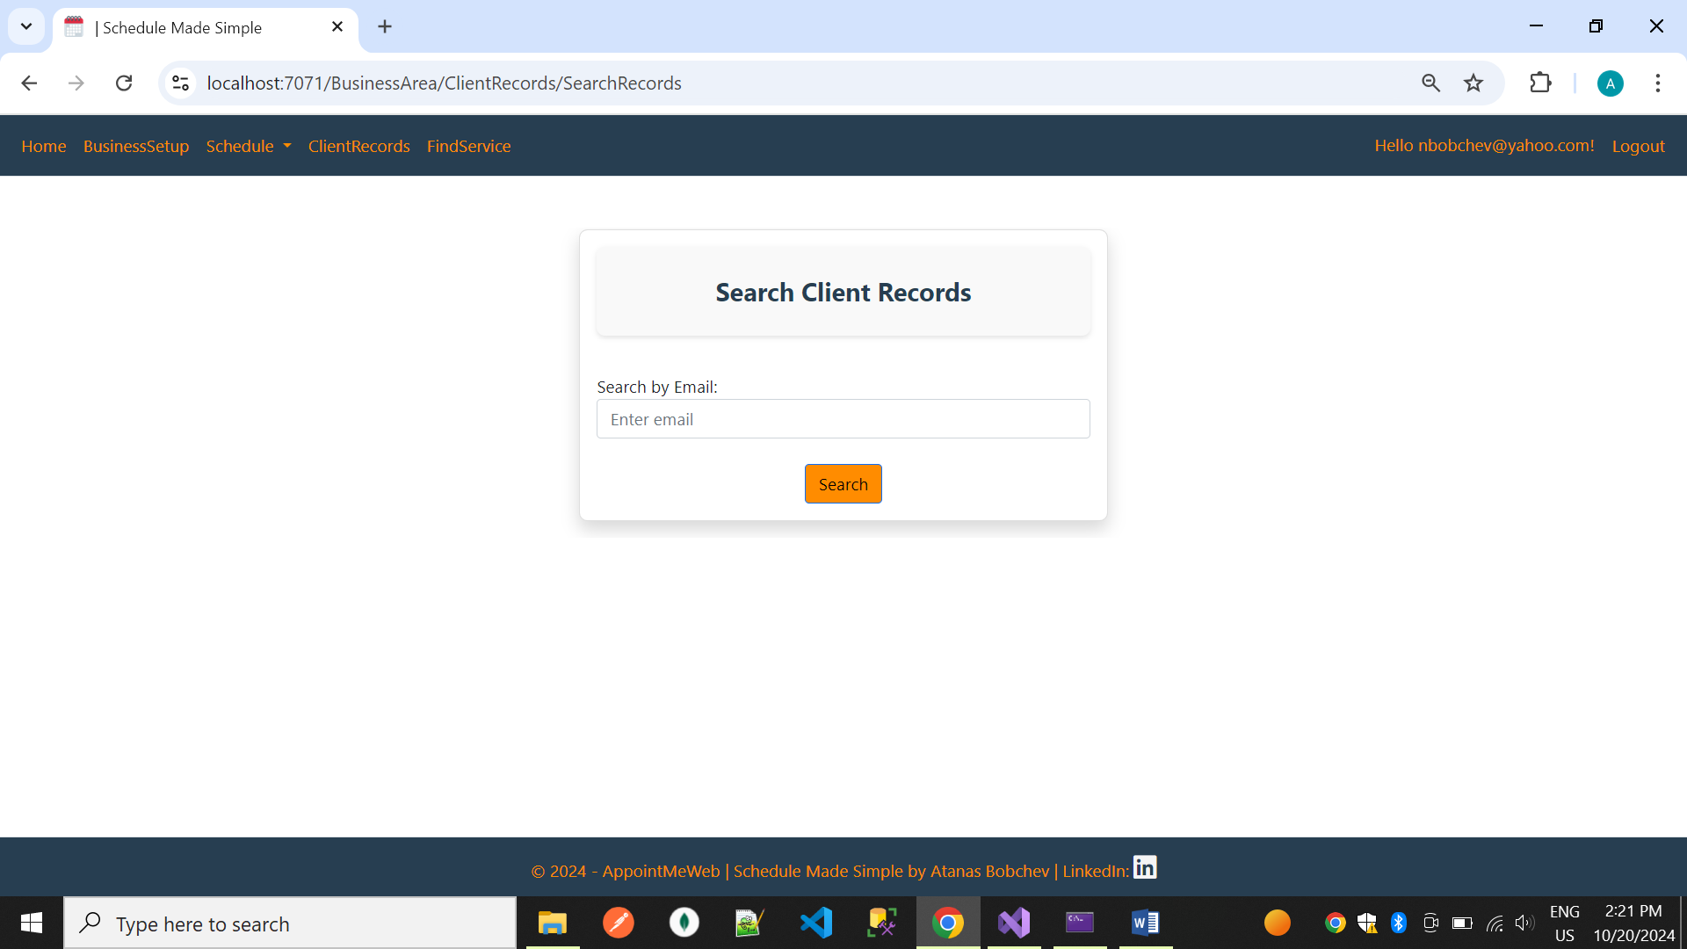

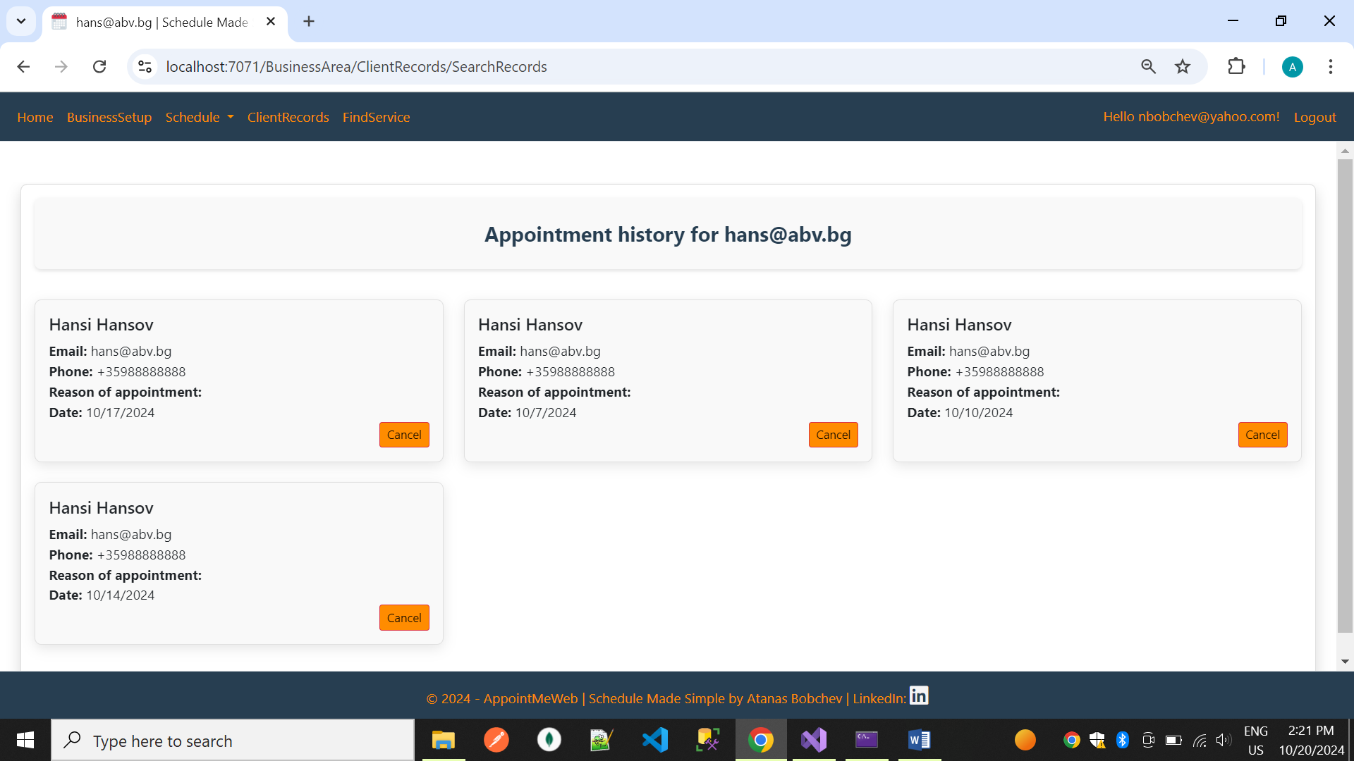

USER AREA

12.USER MAKE APPOINTMENT

